2017 Dakota 9-1-1 Conference

Radisson Hotel  Fargo, ND

September 18-21, 2017

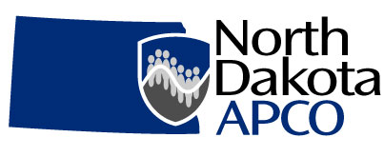

Pre-Conference Class on Monday is a separate fee - $125/person.

Registration Fees: Full conference $225 or $100/Day/Person (Fees include all events/meals.)

Agency Name:

Email Address:

Agency Address: City:

State: Zip: Telephone:

|  |  |  |  |  |  |  |
| --- | --- | --- | --- | --- | --- | --- |
| Attendee | Title | Days Attending | | | | T-Shirt Size |
|  |  | Mon | Tues | Wed | Thurs |  |
|  |  | Mon | Tues | Wed | Thurs |  |
|  |  | Mon | Tues | Wed | Thurs |  |
|  |  | Mon | Tues | Wed | Thurs |  |
|  |  | Mon | Tues | Wed | Thurs |  |
|  |  | Mon | Tues | Wed | Thurs |  |
|  |  | Mon | Tues | Wed | Thurs |  |

**Registration Total Enclosed** $

**Mail Registration Payable to ND APCO**

**by September 1, 2017 to:**

**Red River Regional Dispatch Center**

**Attn: Chantel Shorey, Secretary**

**300 NP Ave Ste. 206**

**Fargo, ND 58102**

**(701)-451-7660**

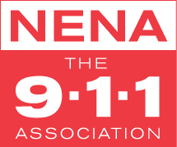

**Registration Policies:**

* Registration is not considered complete until payment is received.
* Refunds:
  + Requests for refund must be submitted to the APCO Chapter Secretary
  + Full refunds are issued if request is received more than 30 days prior to event.
  + Refund requests within 30 days of the event are refunded for ½ the fee paid.
  + Refunds are issued to the agency or person who paid for the registration.
  + Refund can be taken as cash value or as actual value credited toward a future ND APCO event. Credit must be used within two years of issuance.

Attendees Are Required To Make Their Own Lodging Arrangements:

Call 701-232-7363 to get the special block rate $125 per night

Radisson Hotel Fargo, 201 5th St N, Fargo ND 58102